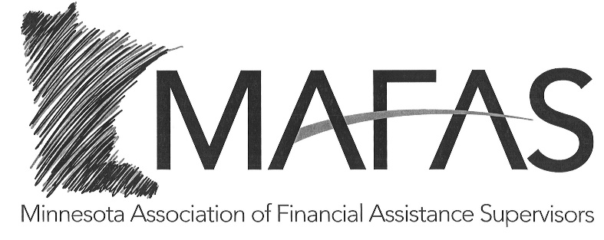

2021 MAFAS MEMBERSHIP
Cost: $45.00

If you wish to become or continue as a member of MAFAS in 2021, please complete the following information and return this form with your payment.

Name:

Agency:

Address:

Email address:

Telephone:

Make membership check payable to MAFAS—if paying with one check but for multiple Supervisors please put their names on the check invoice.

Please return the completed form and membership check to the address listed below.

Stearns County Human Services
MAFAS, Attn: Jennifer Mrnak
PO Box 1107
St Cloud, MN 56302

